Name | JOHN DOLAN
Birth | 11/11/1893 Gateshead
Enlistment/Occupation | Enlisted 4/1/15 / Miner at West Mickley Colliery
Death, date, location | 14/10/1916  Accidentally killed by a revolver bullet negligently discharged by Tyneside Z/5055 AB Harold Brooks Robson, Howe Bn. (who was himself later Killed in action 13/11/16).  Enlisted 4/1/15 ; Draft for MEF 28/6/15, joined Howe Bn. 18/7/15-14/10/16 DD.
Age | 23
Unit, rank,service no: | Able Seaman  Tyneside Z/2753  Royal Naval Volunteer Reserve  Howe Bn. R.N. Div.
Photograph Hexham Courant 25/11/1916 | 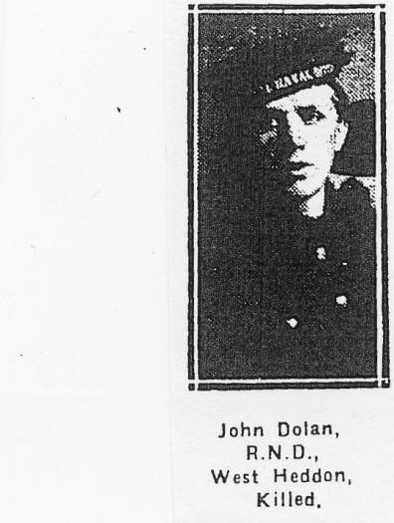
CWGC Family Acknowledgement | Son of Daniel and Isabella Dolan, of Stobhill Farm Cottages, Morpeth, Northumberland. Native of Stocksfield Hall. (CWGC)
Family | John Dolan was born 11/11/1893 in Gateshead, the eldest son of ten surviving children of Daniel Dolan of South Shields and his wife Isabella (nee Miller) also of Gateshead. In 1891 shortly after they were married the Dolans were living in Shipcote Cottages close to Shipcote House where Gateshead Leisure Centre and library now stand. By 1901 the family had moved to a cottage at Blakelaw Farm in Kenton where the father Daniel was a cattleman and the mother Isabella was a milkmaid. BY 1910 they living in a house at Wylam Hills farm, but the following year in the 1911 census they had moved to Front Street, Horsley with parents and elder sister working as farm labourer and farm servants. John aged 17 and his brother Daniel aged 16 worked as coal miners at West Mickley colliery. There were a further five sisters Joanna 19, Isabella 11, Mary 9, Annie 6, and Mable 2 and a younger brother Eddie all living at home.  John enlisted into the Royal Naval Volunteer Reserve on 04/01/1915 location unknown. He was drafted for the Marine Expeditionary Force 28/06/1915 and joined the Howe Battalion 18/07/1915 until his death on 14/10/1916. He served in the Dardanelles action at Gallipoli  The record shows that at the time of his enlistment his ‘next of kin’ and home address are given as Father, Daniel Dolan, Hall Farm, Stocksfield-on-Tyne, later of: West Heddon Dairy's Wylam, Northumberland  A report in the Hexham Courant dated 25/11/1916 of John Dolan’s death includes the information that he joined up in January 1915 and trained at Crystal Palace. He went to the Dardanelles in June 1915 then to Egypt and finally to France. He was accidentally killed on 14/10/1916. He had been a miner at West Mickley. There was a letter from his Commanding Officer expressing regret at his loss and commending his admirable personal qualities. There was a photo of John Dolan in the same newspaper.  A further report in the Hexham Courant on 20/09/1918 records that Daniel Dolan, John’s brother had been wounded he was also a member of the RNVR.
Memorials | I. A. 42  VARENNES MILITARY CEMETERY  Also commemorated in:-  War memorial Plaque St.Oswin’s church, Wylam  War Memorial Monument, Village Green,Wylam
Comments | The details of AB Harold Brooks Robson, the person whose negligence caused the death of John Dolan, are copied here from the UK Soldiers died in Great War 1914-1919  Name: Harold Brooks Robson  Service Branch: Royal Naval Volunteer Reserve  Unit: Howe Bn.  Rank: Able Seaman  Death Date: 13 Nov 1916  Cause of Death: Killed in action  Burial: Ancre British Cemetery, Beaumont-Hamel (FR 339)  Service History: Enlisted 2/6/15 ; Draft for MEF 5/12/15, joined Howe Bn. at Mudros 10/1/16-13/11/16 DD.  Service Number: Tyneside Z/5055  Notes: Field General Court Martial 29/10/16, sentenced to 6 months Imprisonment with Hard Labour for (1) Manslaughter (not guilty) (2) Conduct to the prejudice of Good order & Military discipline (negligently discharged a revolver & caused injury to Tyneside Z/2753 AB J. Dolan, who died 14/10/16) (Guilty) ; GOC directs that prisoner be not committed to prison until further orders. Commuted to 1 month's Field Punishment No.1 (undated). ; b.1/4/1896. A Miner (Rope Lad) at Preston Colliery. ; Next-of-Kin & home address: Father, Alec., 40 Church St., North Shields, later of: 25 Charlotte St., N.Shields. ; ADM/171 = St.V.B. issued to Father.
Field Punishment No.1 | Harold Brooks Robinson who was responsible for accidentally killing John Dolan had his sentence commuted to 1 month’s Field Punishment No.1 which is described below. In the event Harold himself was killed in action 15 days after his court martial.  Field Punishment No:1 was introduced in 1881 following the abolition of flogging, and was a common punishment during World War I. A commanding officer could award field punishment for up to 28 days, while a court martial could award it for up to 90 days, either as Field Punishment Number One or Field Punishment Number Two.  Field Punishment Number One, often abbreviated to "F.P. No. 1" or even just "No. 1", consisted of the convicted man being placed in fetters and handcuffs or similar restraints and attached to a fixed object, such as a gun wheel, for up to two hours per day. During the early part of World War I, the punishment was often applied with the arms stretched out and the legs tied together, giving rise to the nickname "crucifixion". This was applied for up to three days out of four, up to 21 days total. It was usually applied in field punishment camps set up for this purpose a few miles behind the front line, but when the unit was on the move it would be carried out by the unit itself. It has been alleged that this punishment was sometimes applied within range of enemy fire. During World War I Field Punishment Number One was issued by the British Army on 60210 occasions.  In both forms of field punishment, the soldier was also subjected to hard labour and loss of pay.  Field Punishment Number One was eventually abolished in 1923,
Sources | UK Soldiers died in Great War 1914-1919  Commonwealth War Graves Commission  1891/1901/1911 Census  Hexham Courant 25/11/1916 (Photo)

